**ASSIGNMENT 2**

1. select s.name, c.cust_name, c.city

from salesman s

inner join customer c

on s.city = c.city

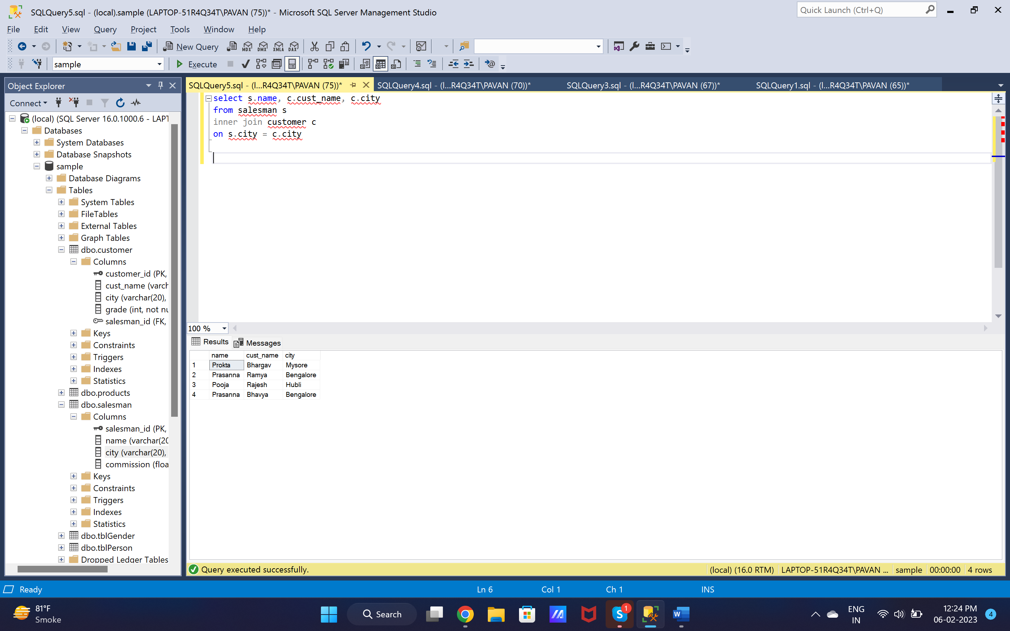

1. SELECT o.ord_no, o.pur_amt, c.cust_name, c.city

from orders

inner join customer c

on o.customer_id = c.customer_id

where o.pur_amt between 500 AND 2000

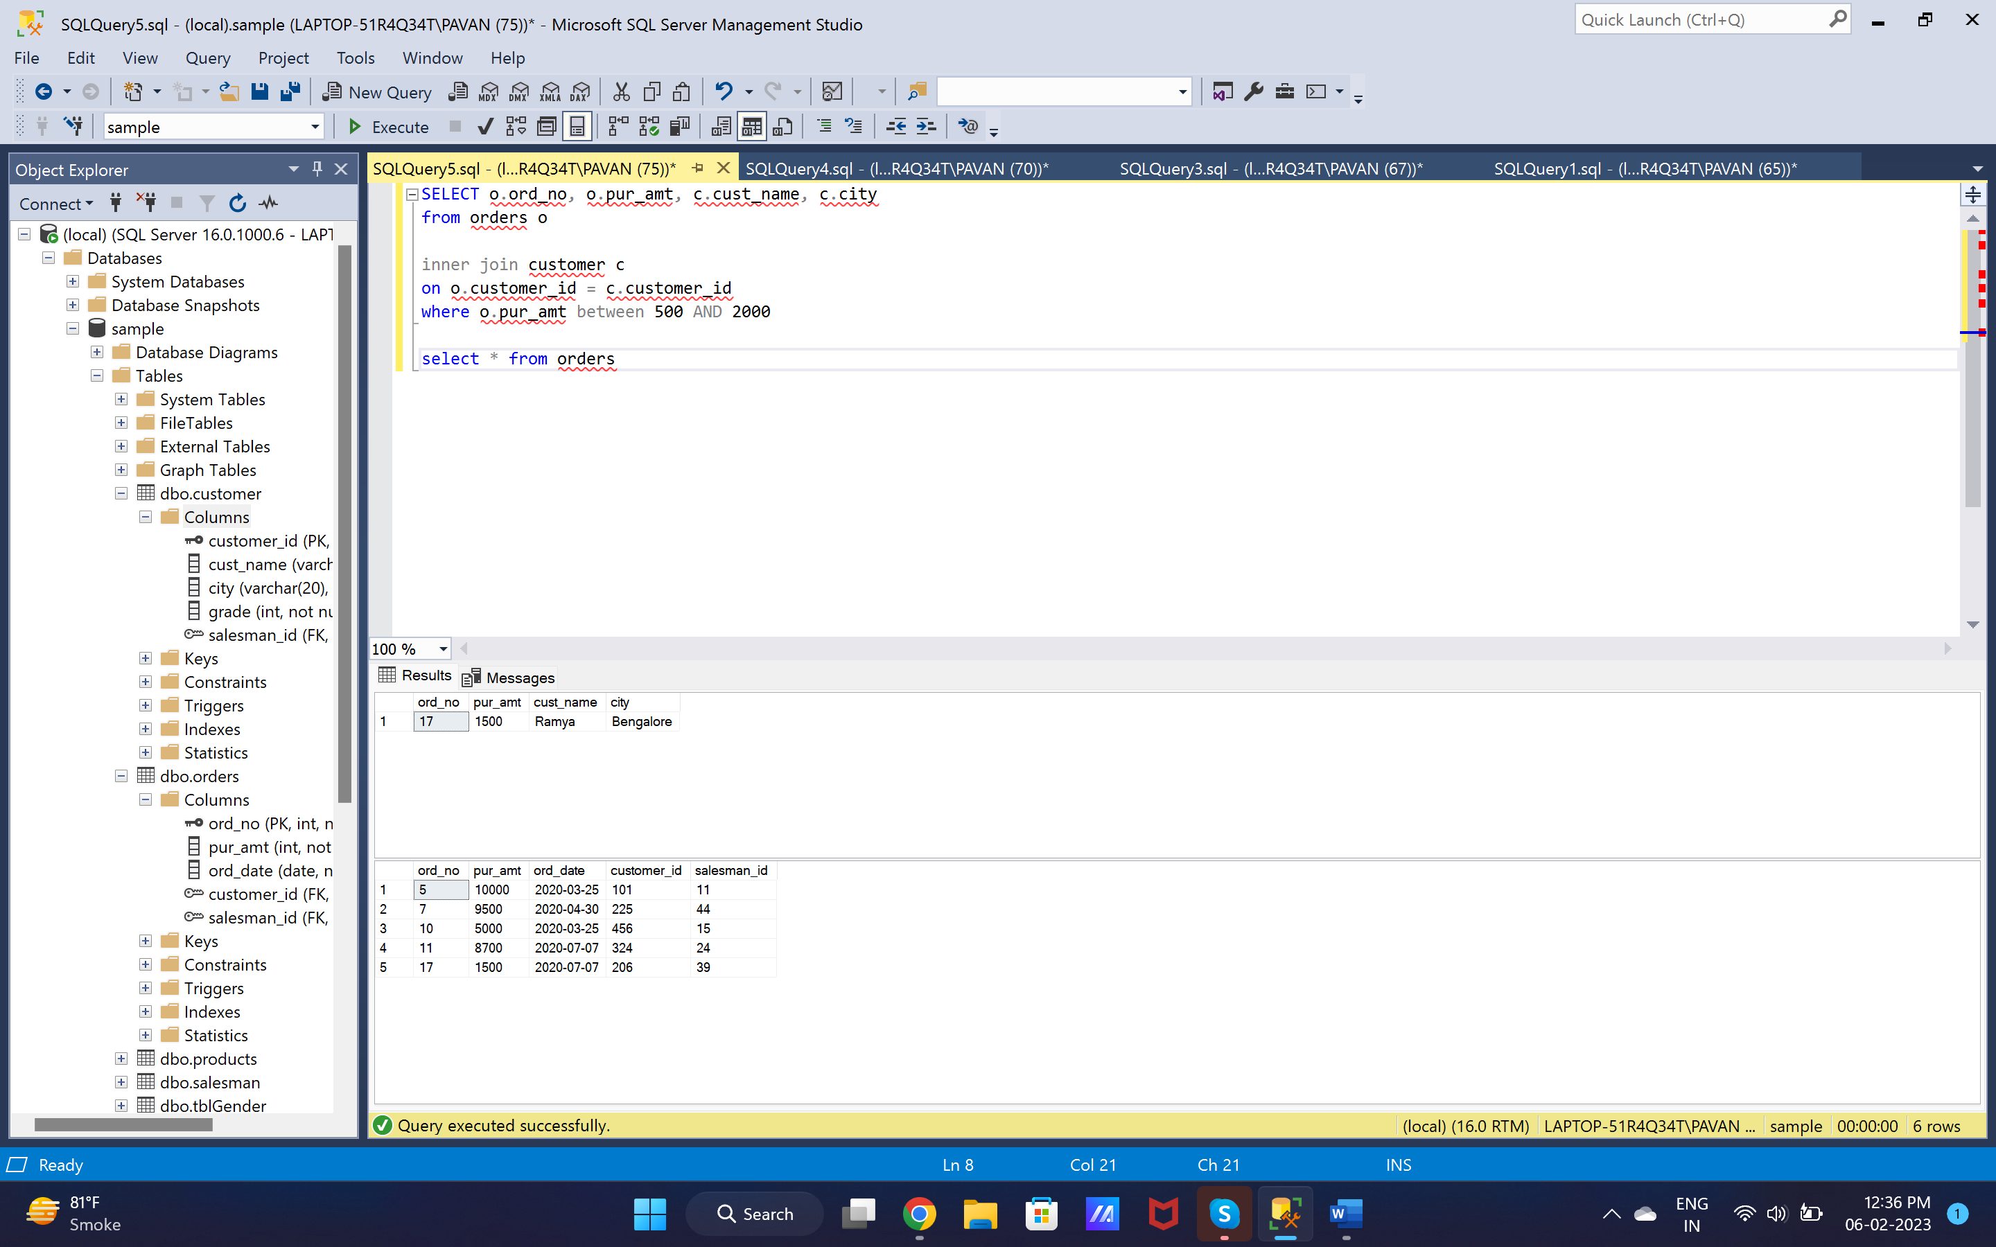

1. select s.name as SalesPerson, c.cust_name, c.city, s.commission

from salesman s

inner join customer c

on c.salesman_id = s.salesman_id

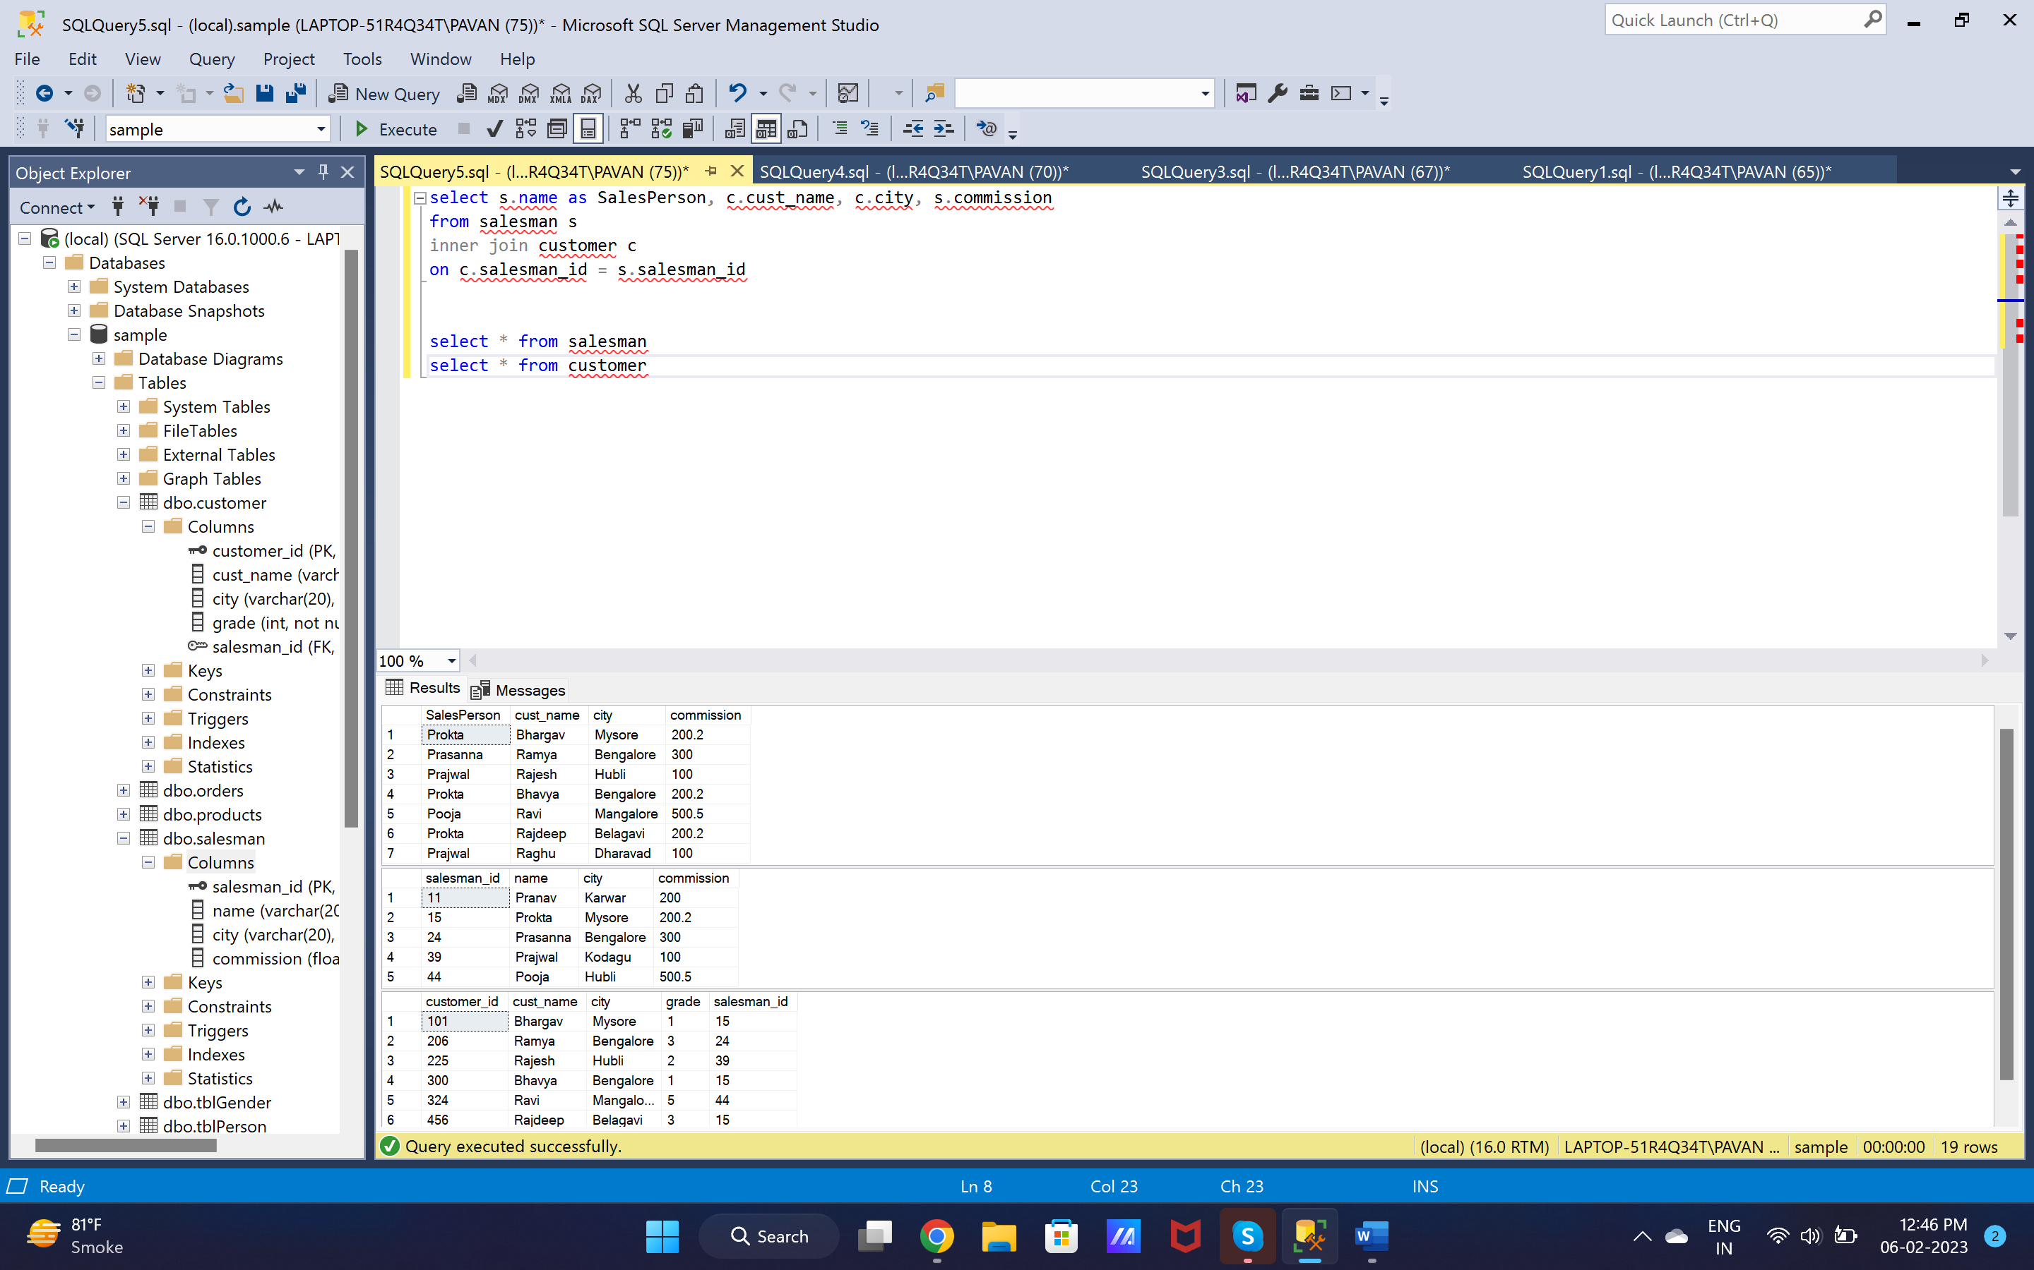

1. select s.name as SalesPerson, c.cust_name, c.city, s.commission

from customer c

inner join salesman s

on c.salesman_id = s.salesman_id

where s.commission > 120

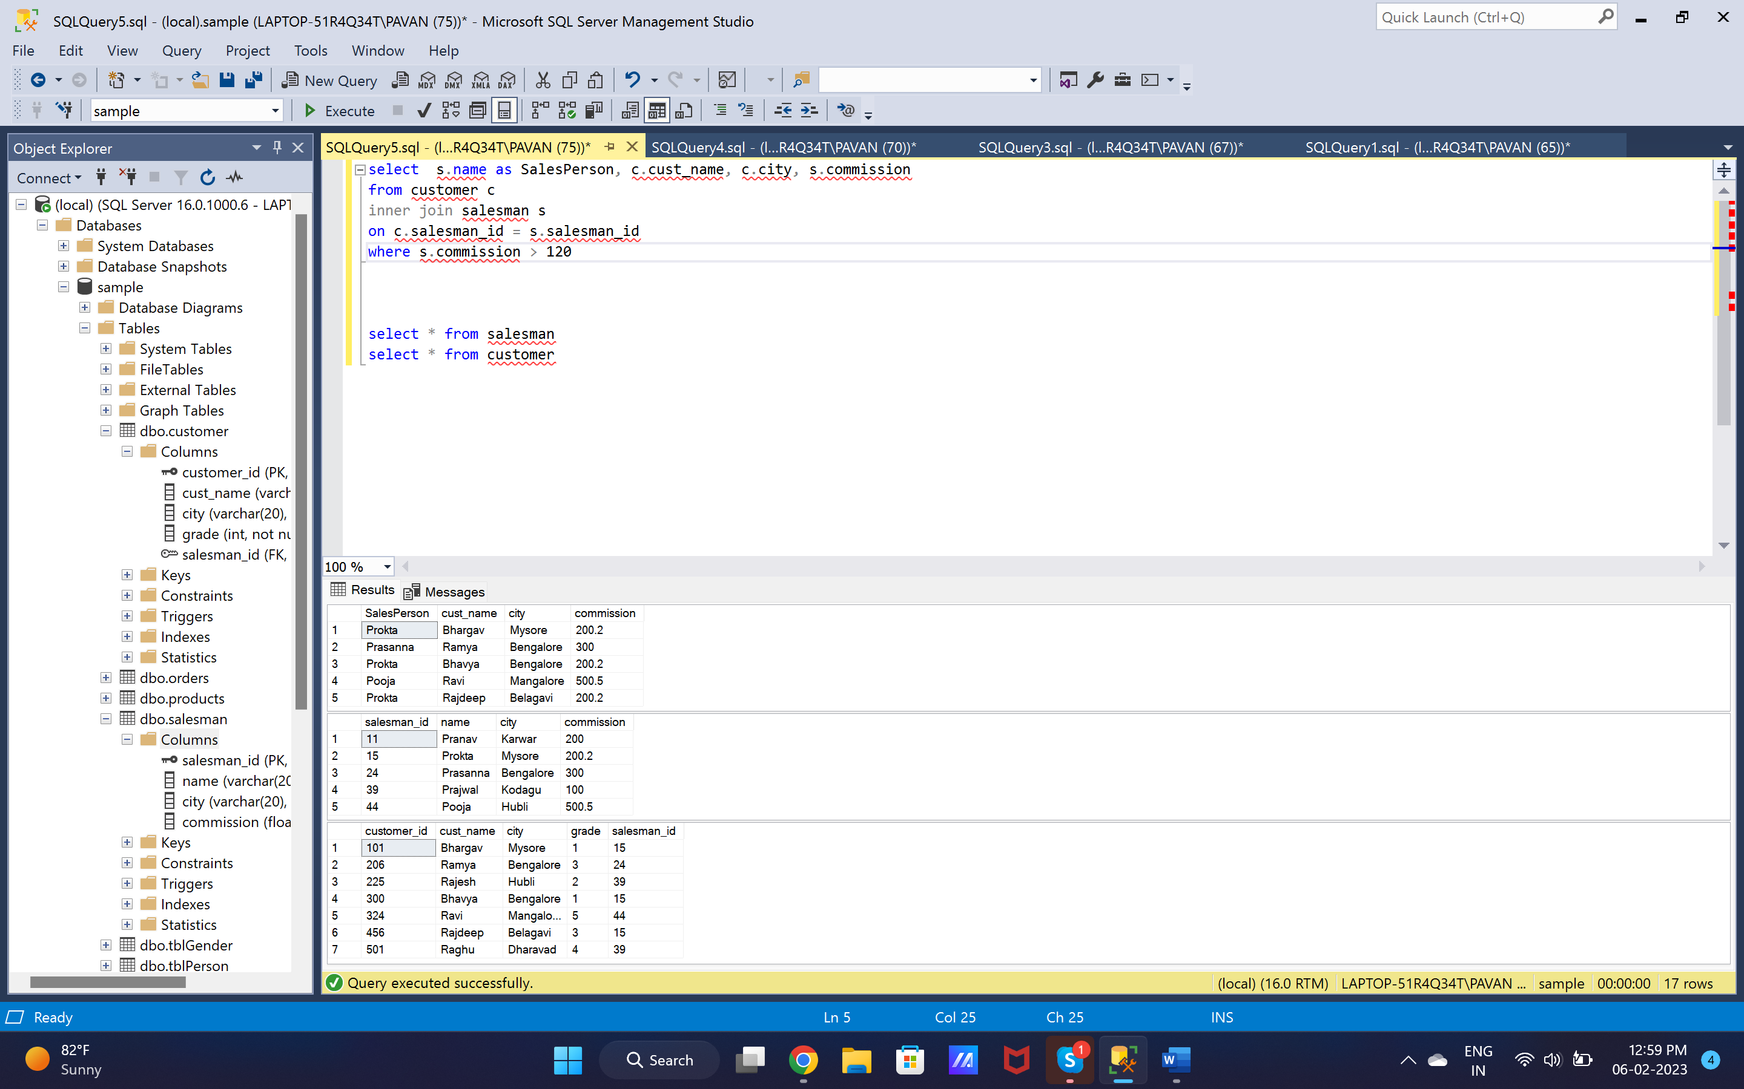

1. select s.name as SalesPerson, c.cust_name, c.city as CustomerCity, s.commission, s.city as SalesmanCity

from customer c

inner join salesman s

on c.salesman_id = s.salesman_id

where s.commission > 120 AND s.city = c.city

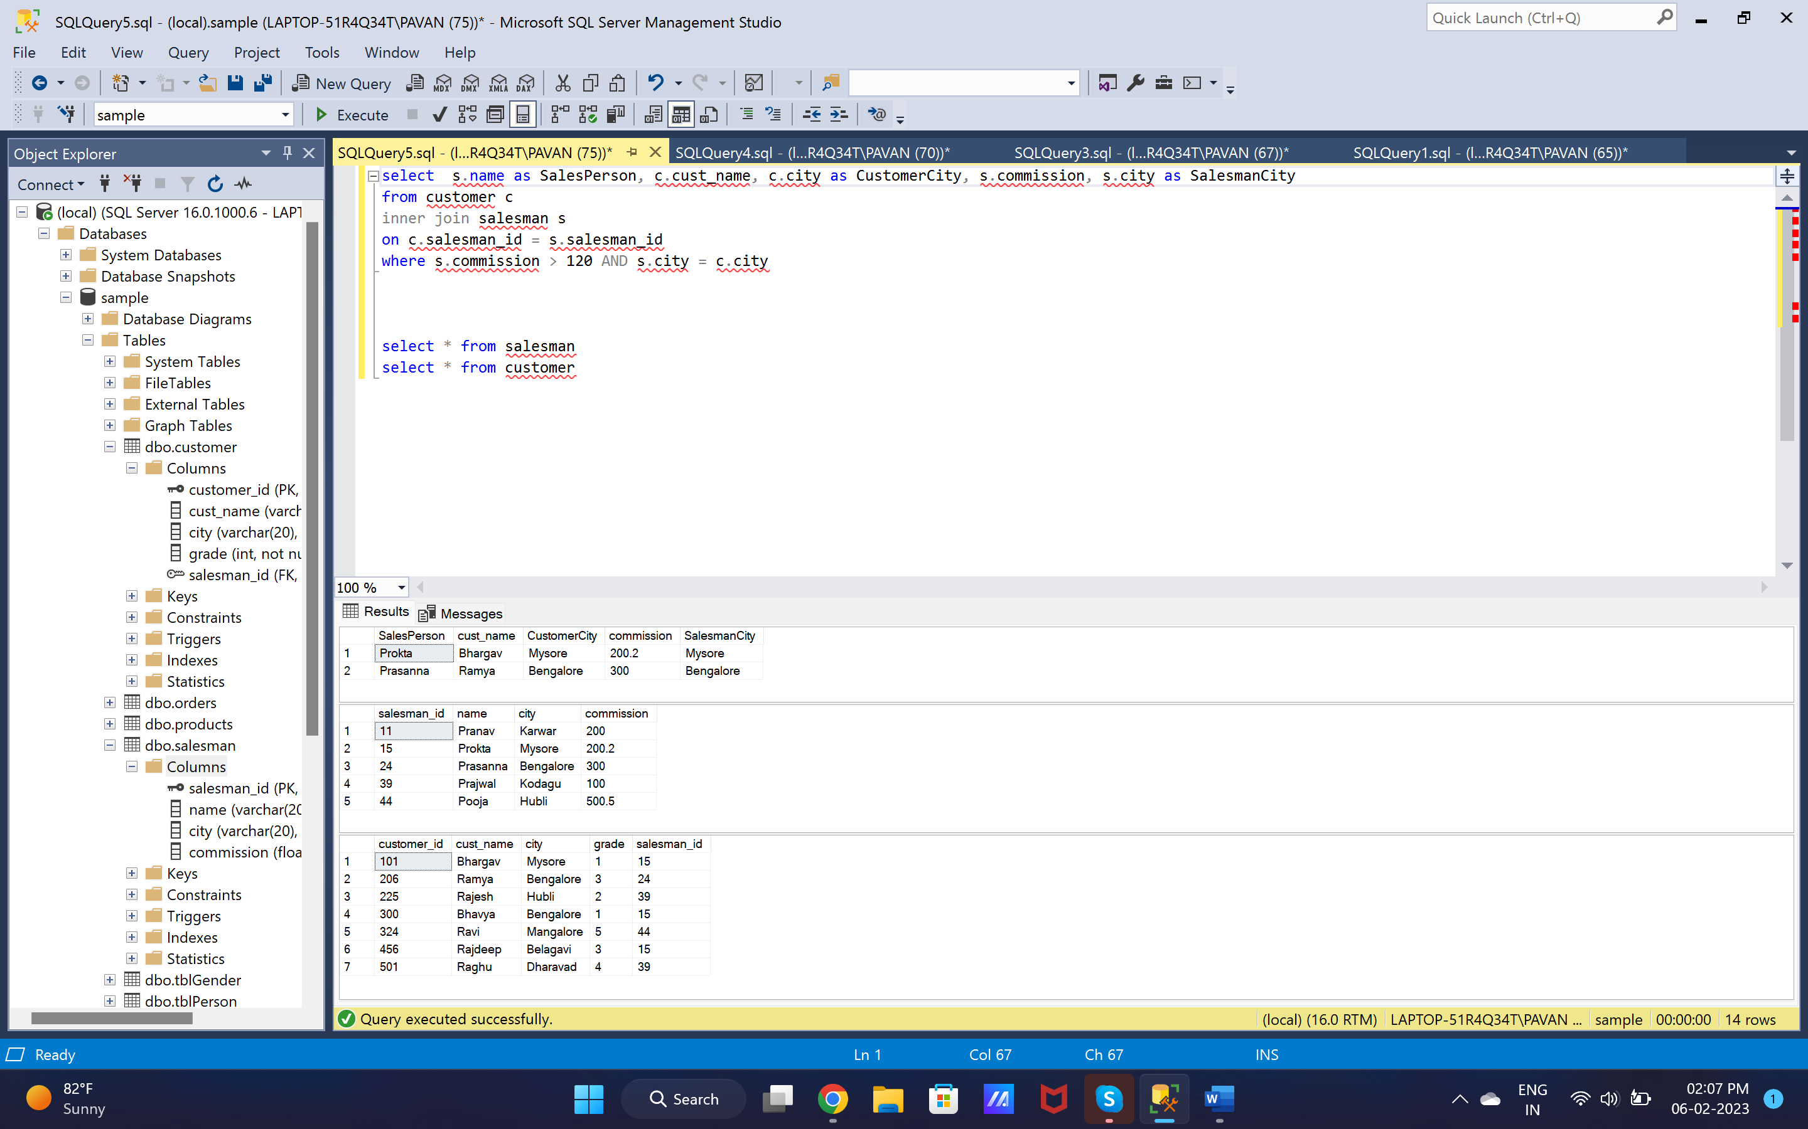

6. select o.ord_no as OrderNo, o.ord_date as Order_date, o.pur_amt as PurchaseAmount,

c.cust_name as CustomerName, c.grade, s.name as SalesmanName, s.commission

from orders o

inner join customer c

on o.customer_id = c.customer_id

inner join salesman s

on o.salesman_id = s.salesman_id\

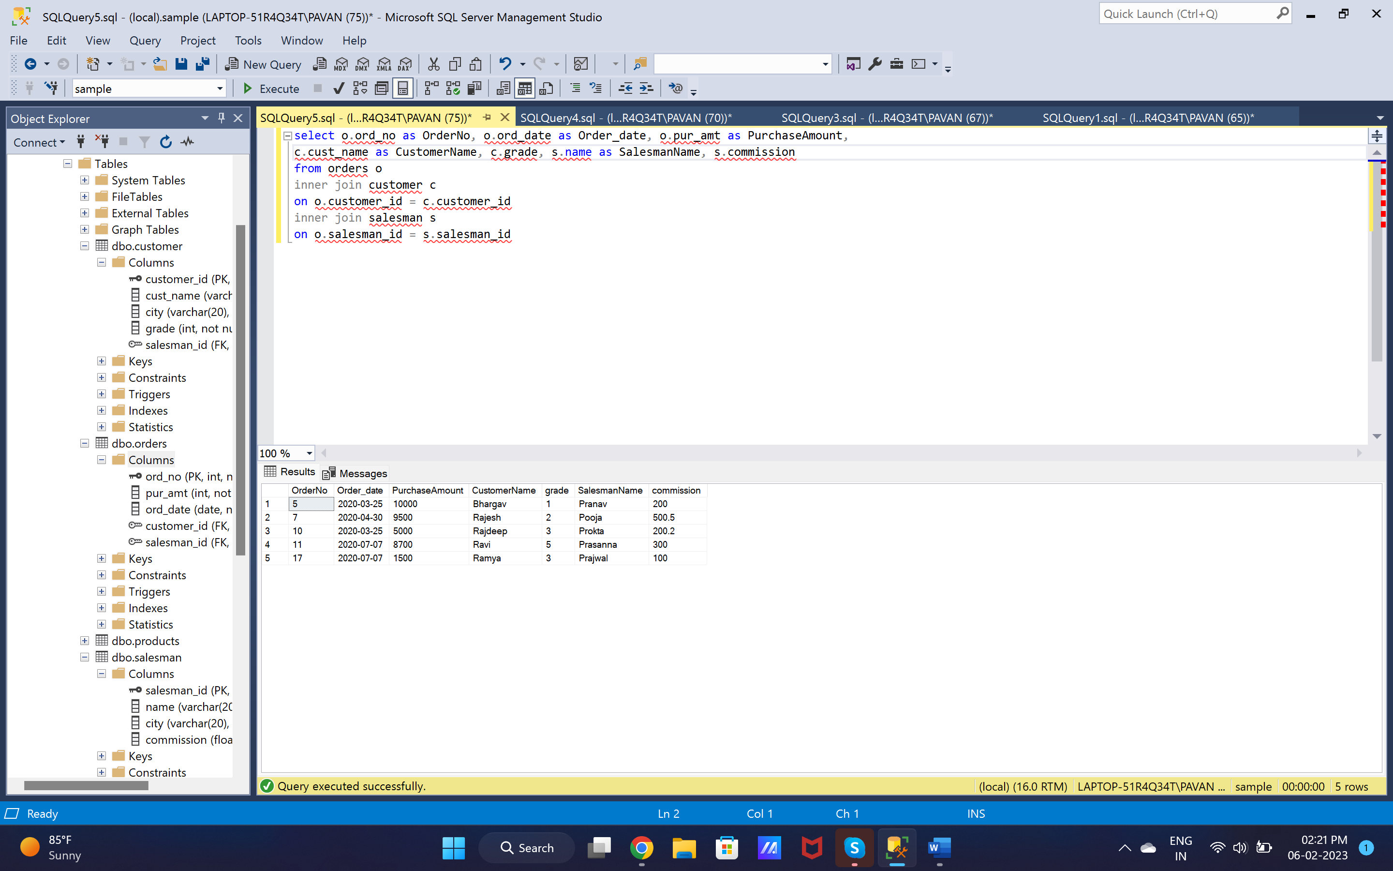

7. select c.customer_id, c.cust_name as CustomerName, c.city as CustomerCity, c.grade,

s.salesman_id, s.name as SalesmanName, s.city as SalesmanCity, s.commission,

o.ord_no as OrderNo, o.ord_date as Order_date, o.pur_amt as PurchaseAmount

from orders o

join customer c

on o.customer_id = c.customer_id

join salesman s

on o.salesman_id = s.salesman_id

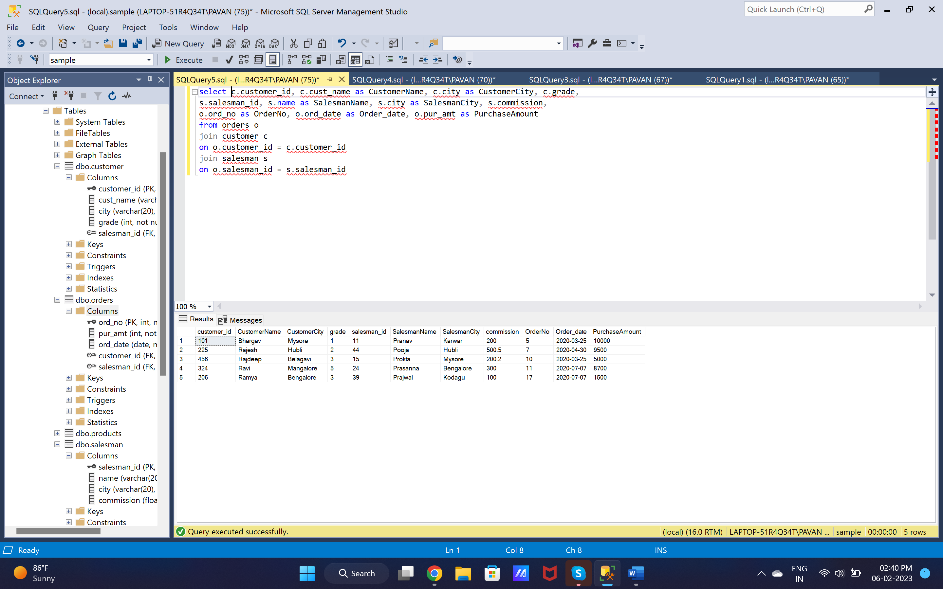

8. select c.customer_id, c.cust_name as CustomerName, c.city as CustomerCity, c.grade,

s.name as SalesmanName, s.city as SalesmanCity, s.commission

from customer c

join salesman s

on c.salesman_id = s.salesman_id

order by customer_id

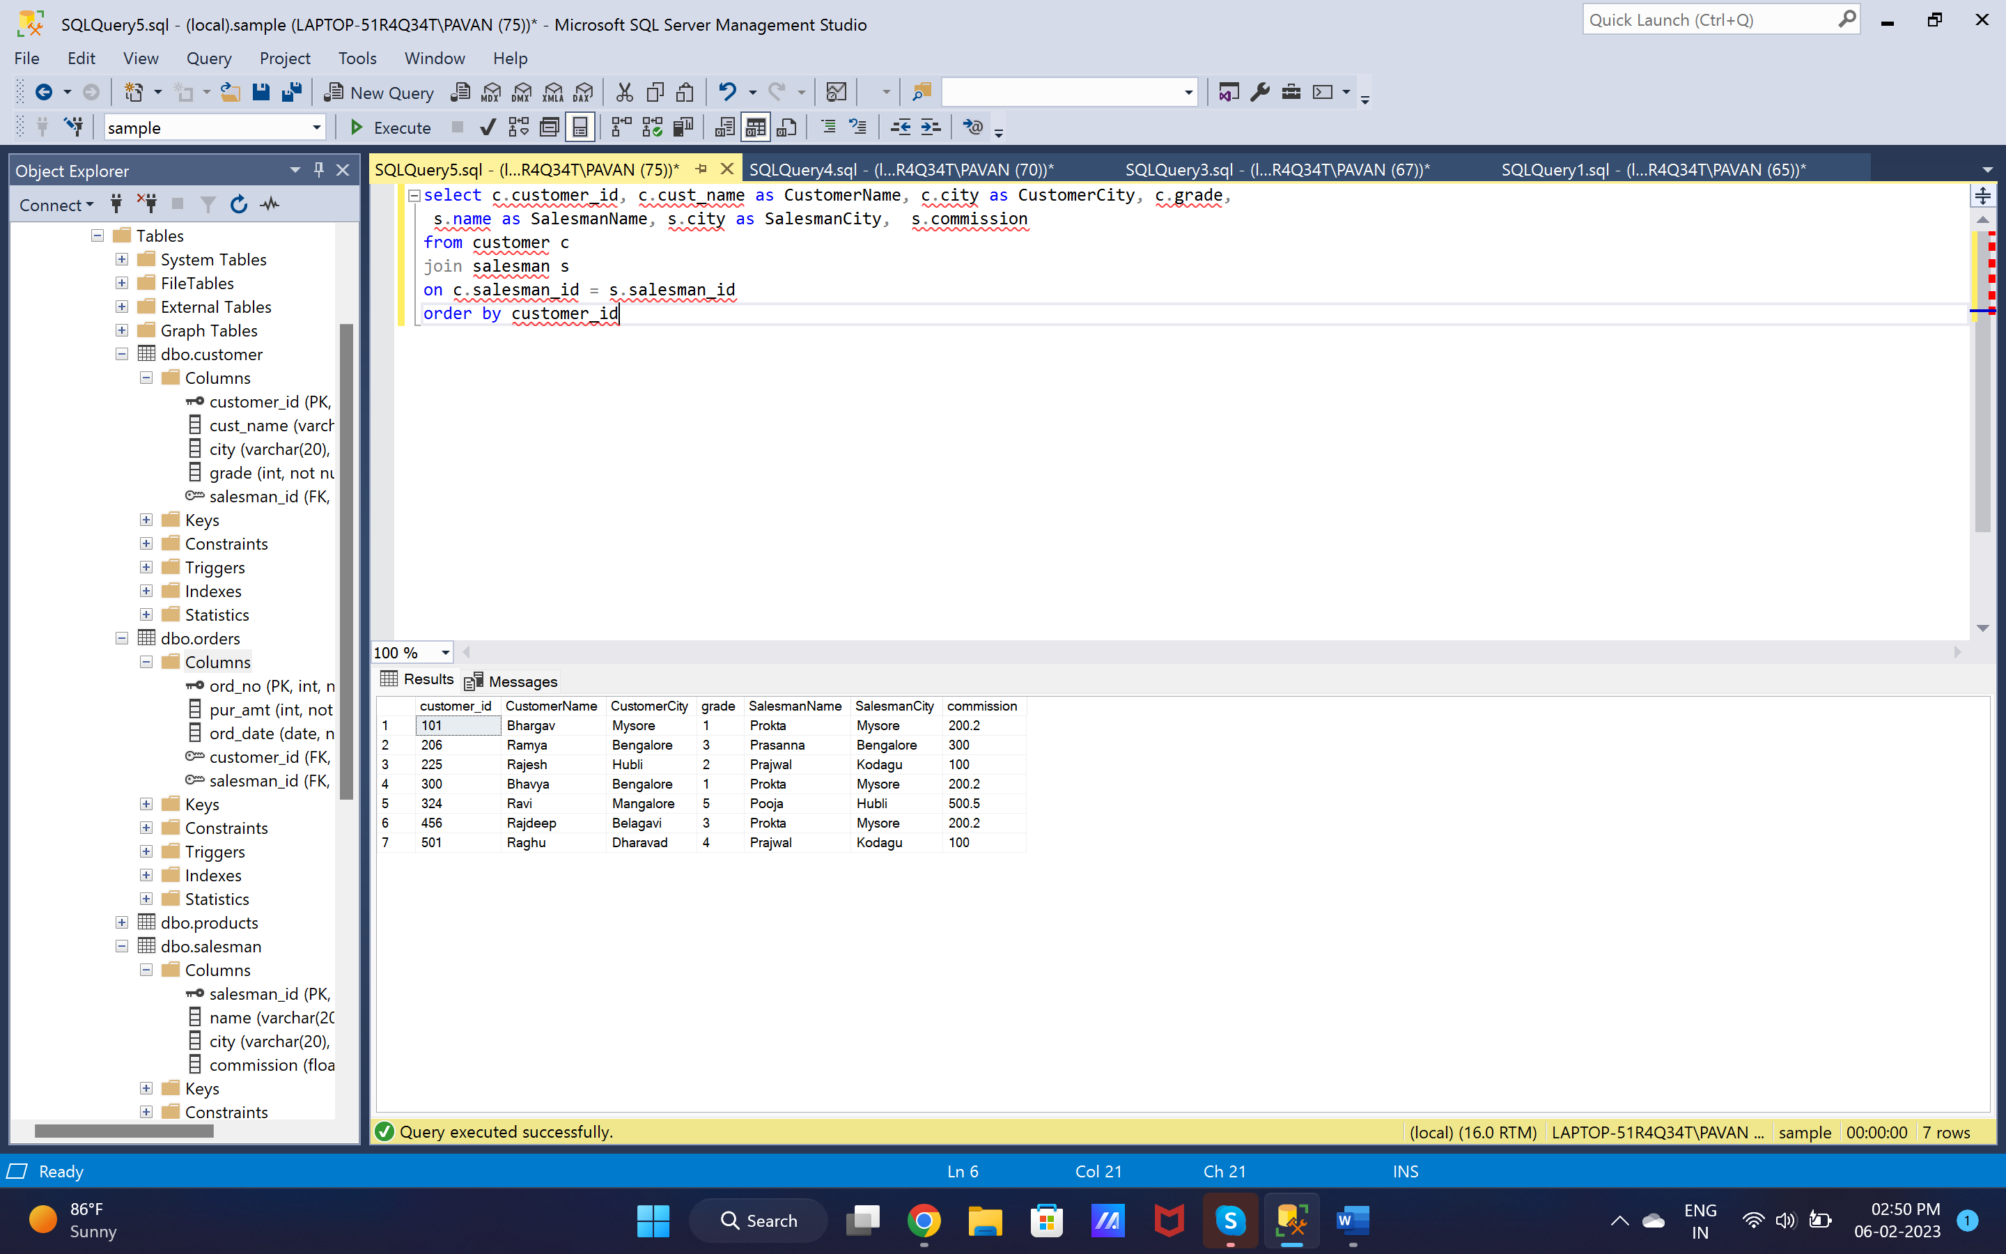

9. select c.customer_id, c.cust_name as CustomerName, c.city as CustomerCity, c.grade,

s.name as SalesmanName, s.city as SalesmanCity

from customer c

join salesman s

on c.salesman_id = s.salesman_id

where c.grade < 3

order by customer_id

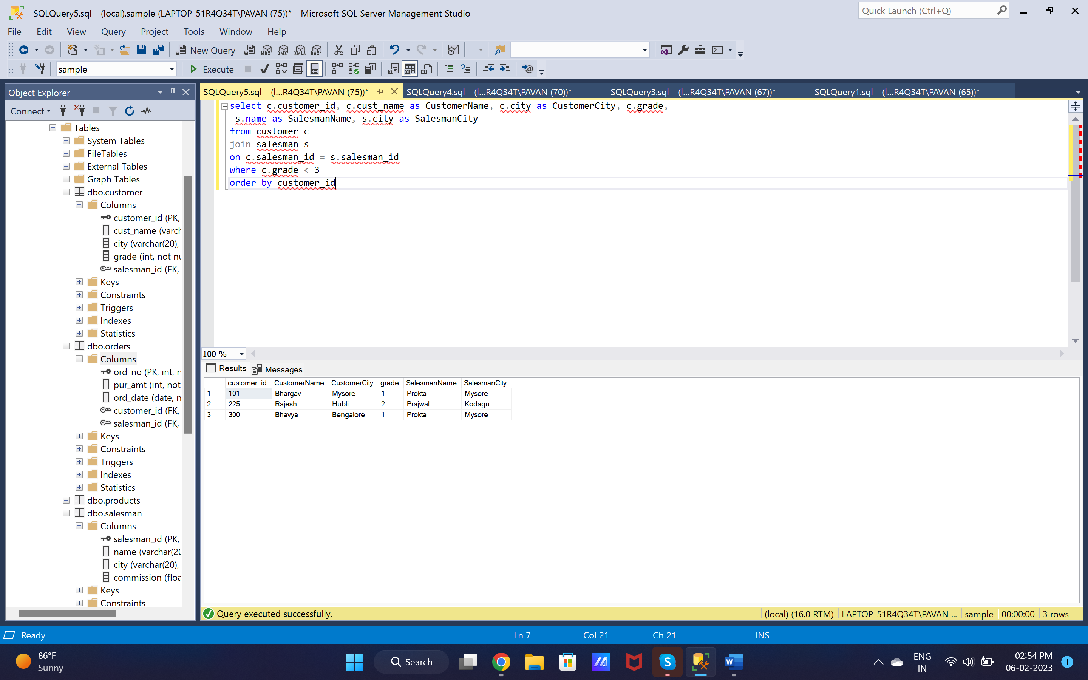

10. select c.cust_name as CustomerName,

c.city as CustomerCity, o.ord_no,

o.ord_date, o.pur_amt

from customer c

left join orders o

on c.customer_id = o.customer_id

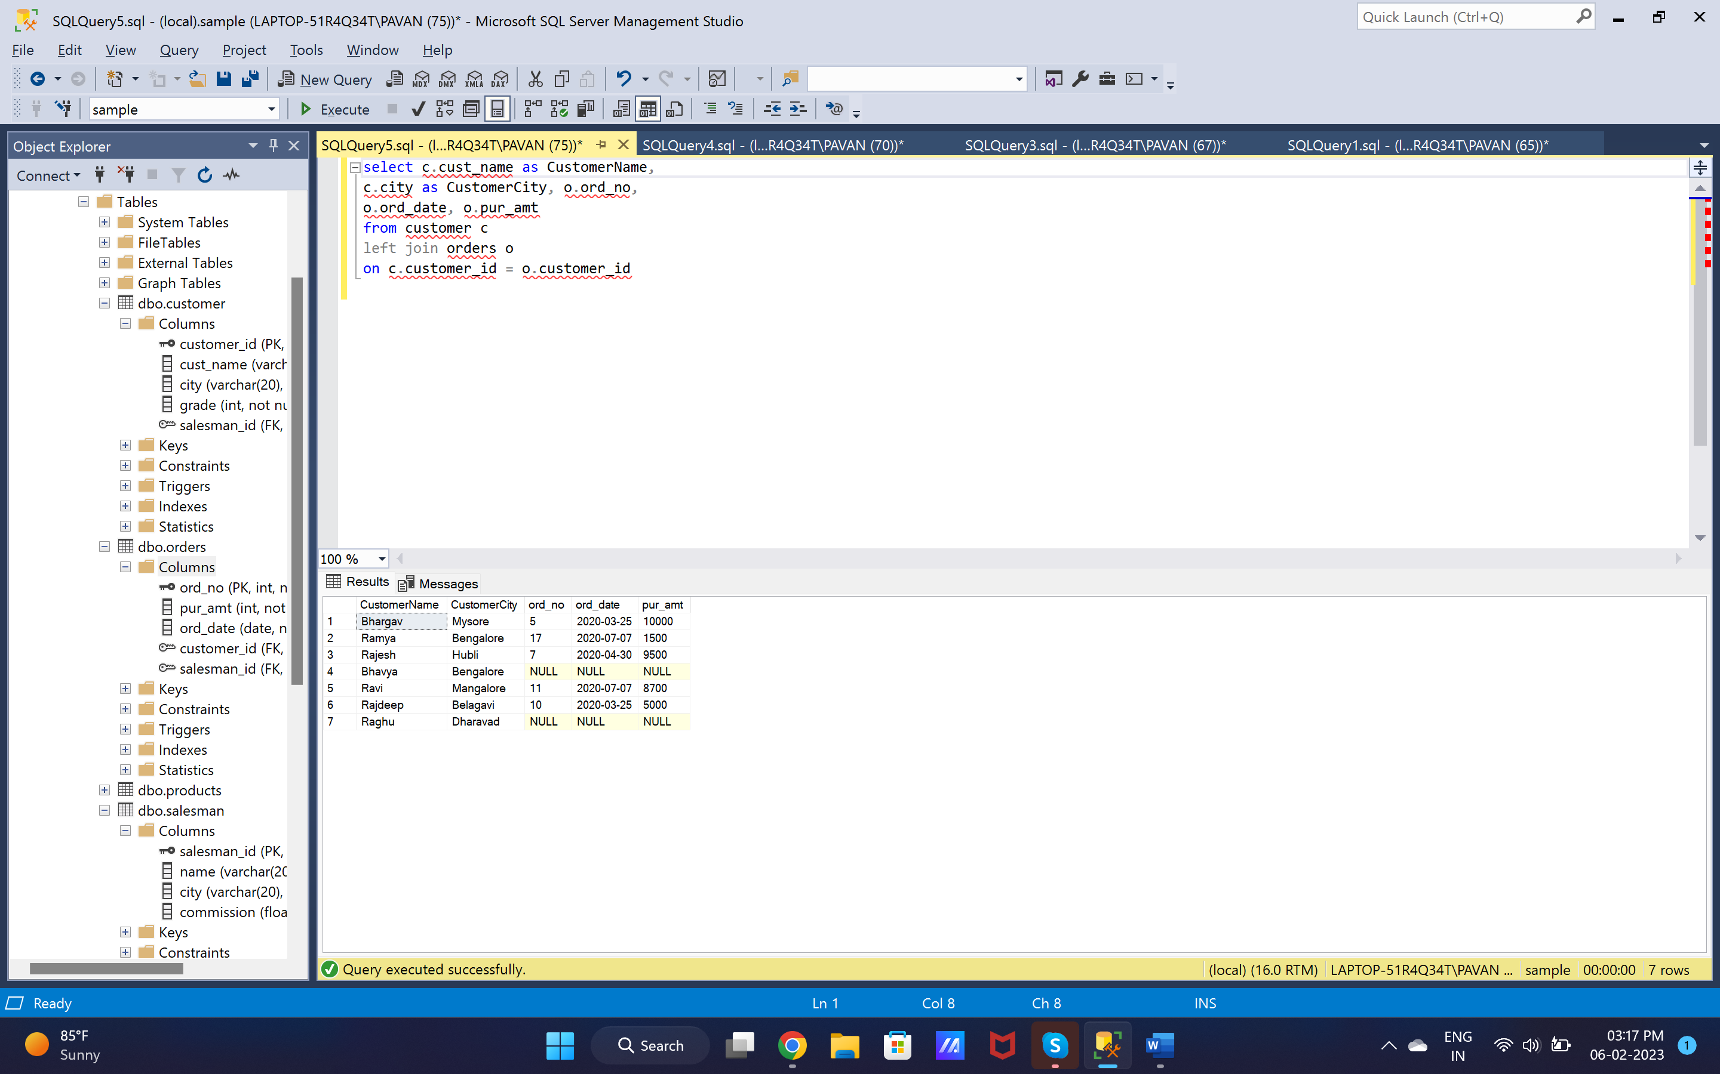

11. select c.cust_name as CustomerName,

c.city as CustomerCity, o.ord_no,

o.ord_date, o.pur_amt, s.name as SalesmanName, s.commission

from customer c

left join orders o

on c.customer_id = o.customer_id

left join salesman s

on o.salesman_id = s.salesman_id

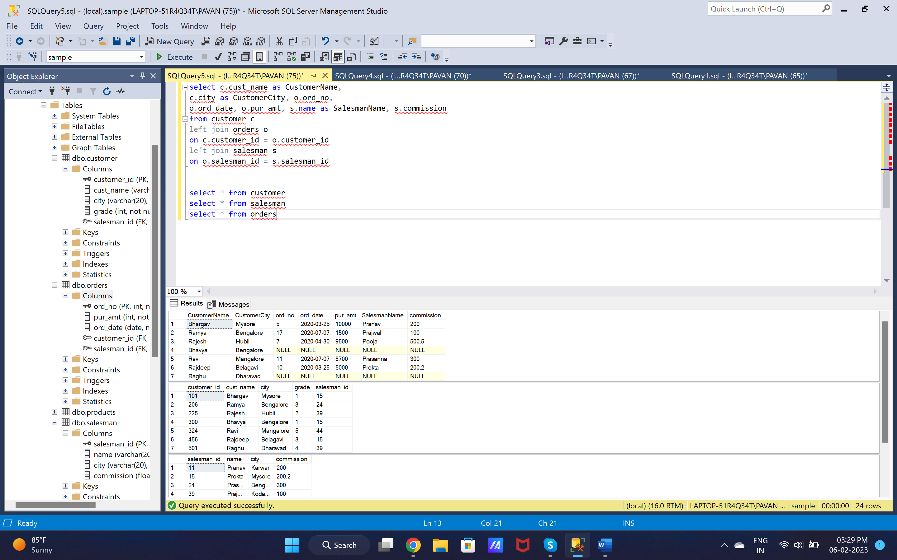

12. select * from salesman s

left join customer c

on s.salesman_id = c.salesman_id

order by s.salesman_id

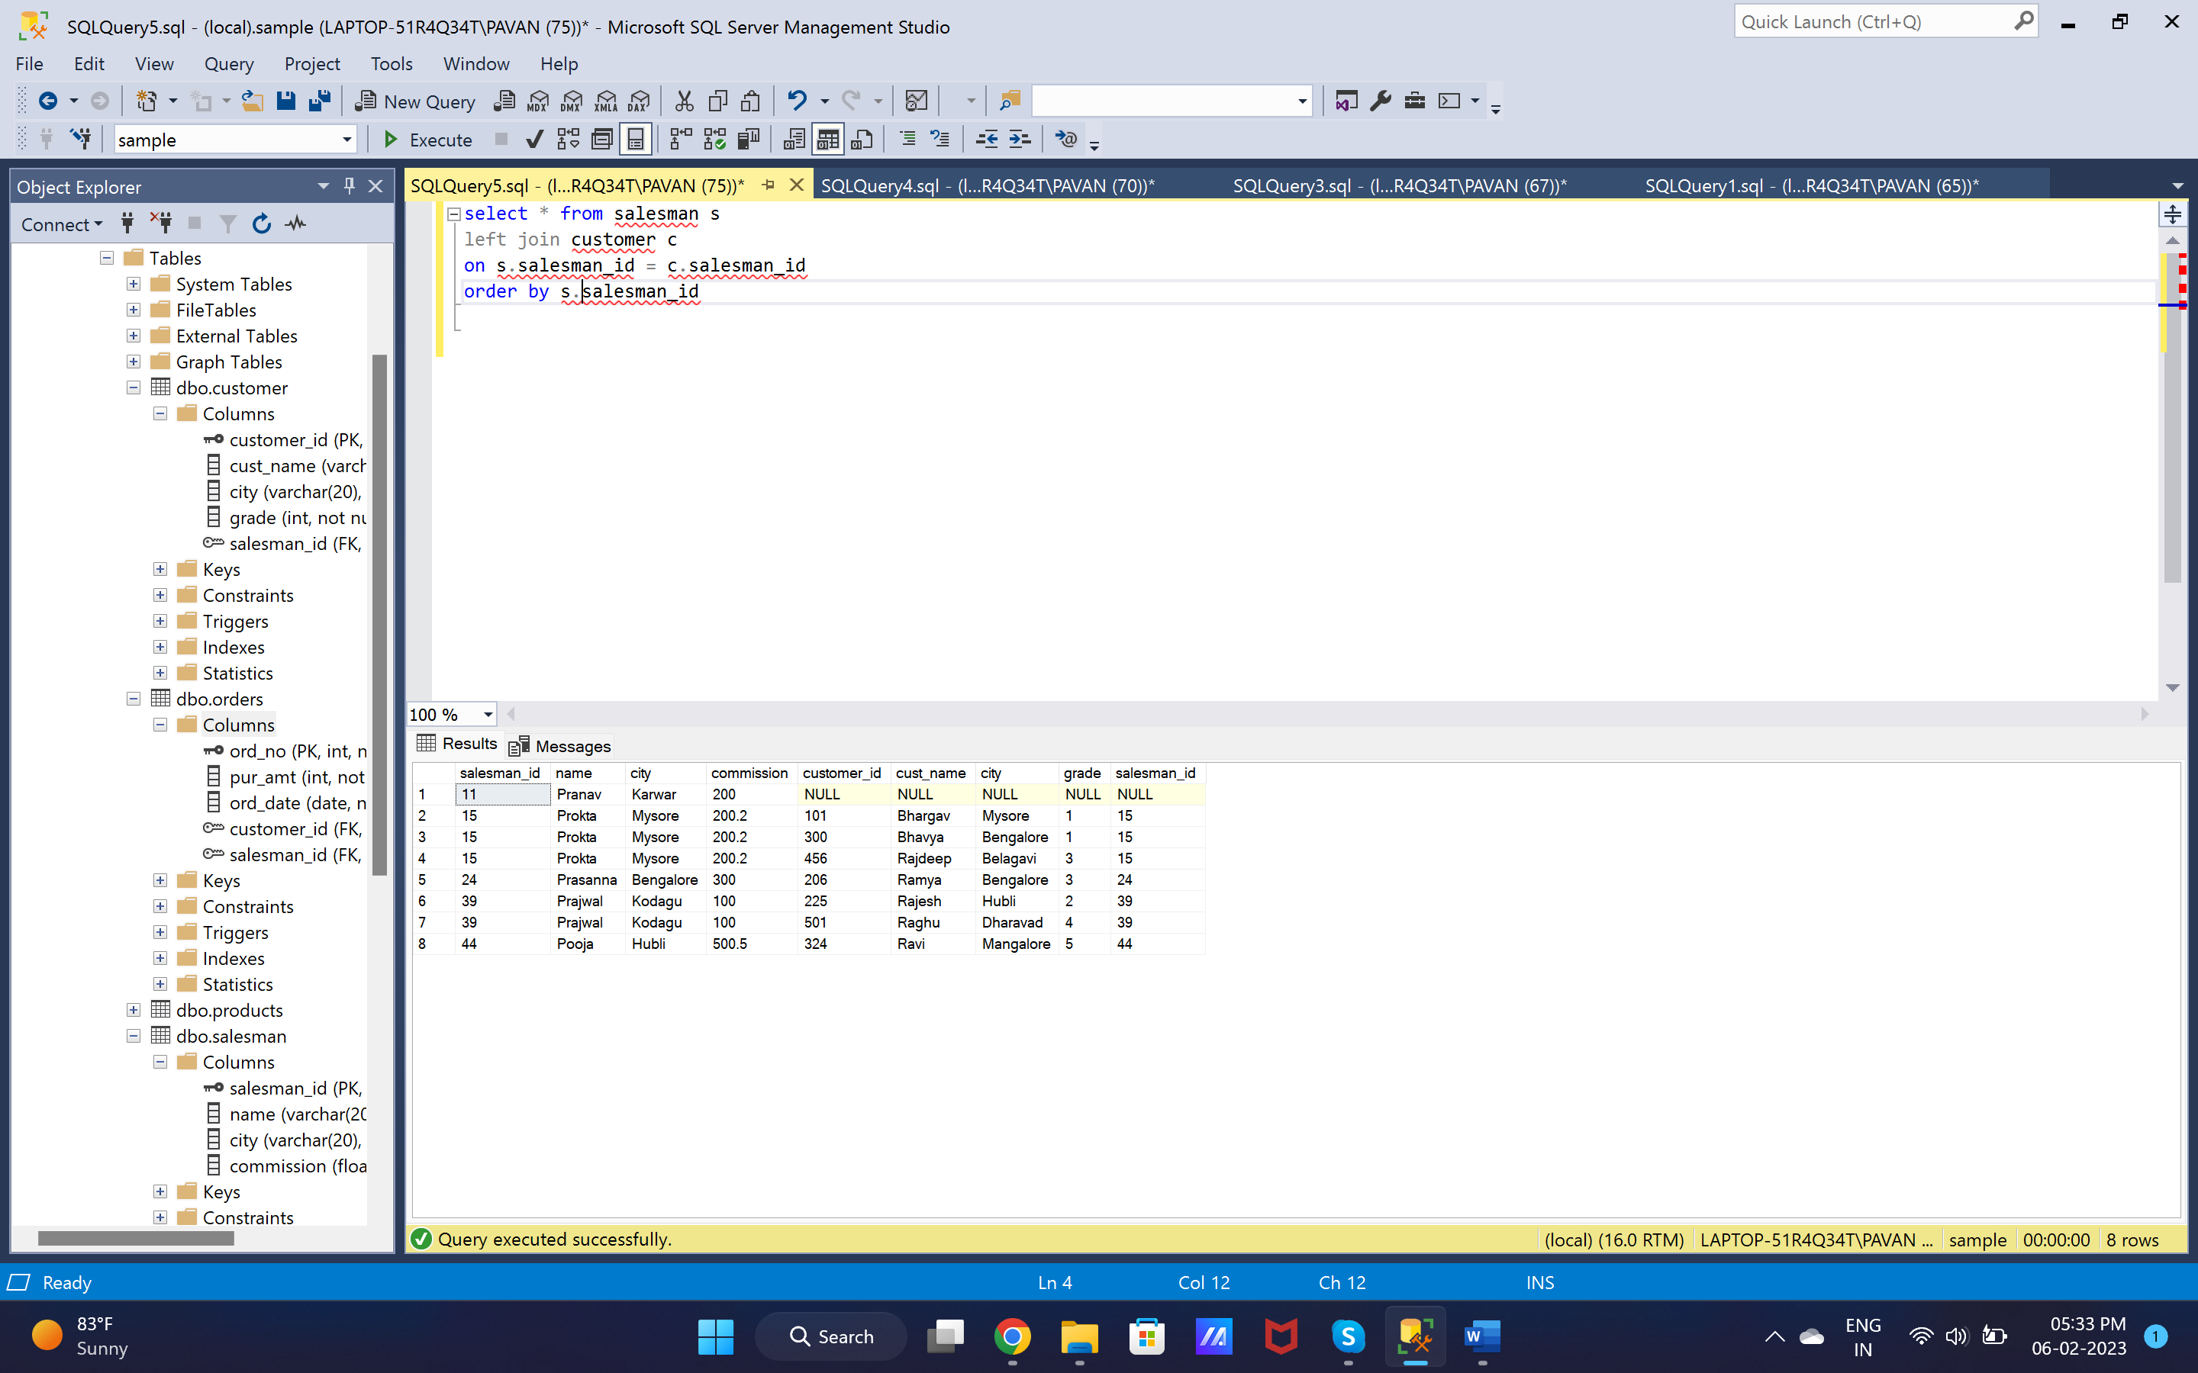

13. select s.name, c.cust_name as CustomerName, c.city, c.grade, o.ord_no as OrderNo,

ord_date as OrderDate, pur_amt as OrderAmount from salesman s

left join customer c

on s.salesman_id = c.salesman_id

left join orders o

on s.salesman_id = o.salesman_id

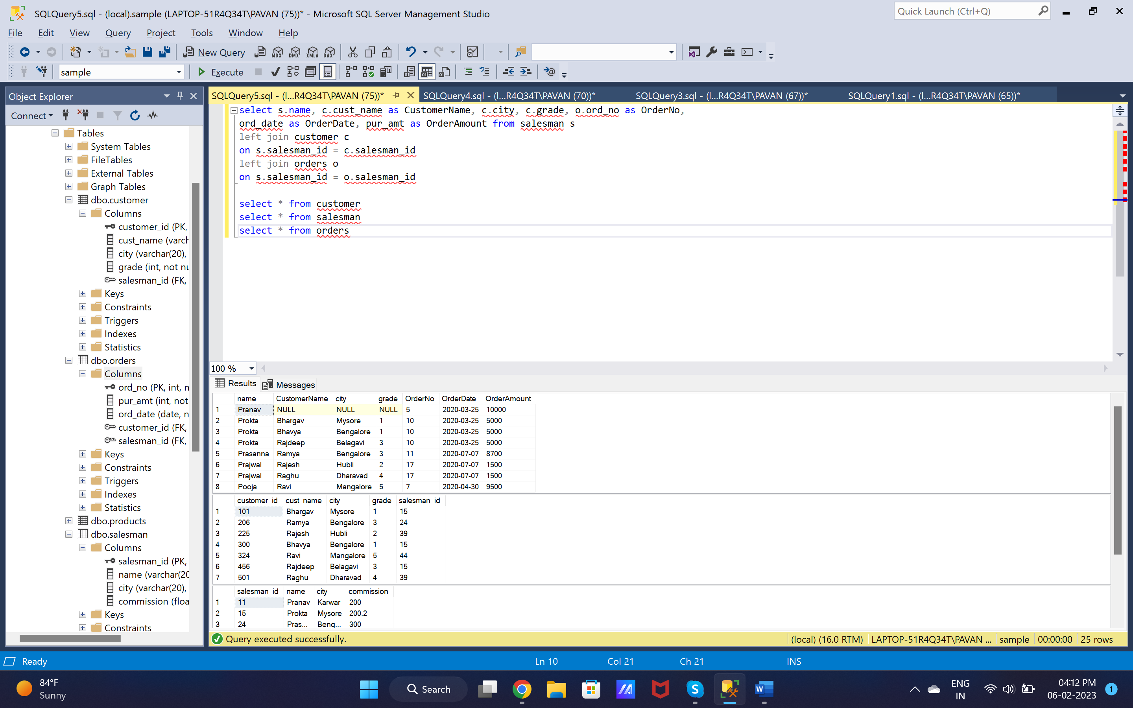

14. select s.name, c.cust_name as CustomerName, c.city, c.grade, o.ord_no as OrderNo,

ord_date as OrderDate, o.pur_amt as OrderAmount from salesman s

left join customer c

on s.salesman_id = c.salesman_id

left join orders o

on s.salesman_id = o.salesman_id

where (o.pur_amt > 2000 AND c.grade is NOT NULL)

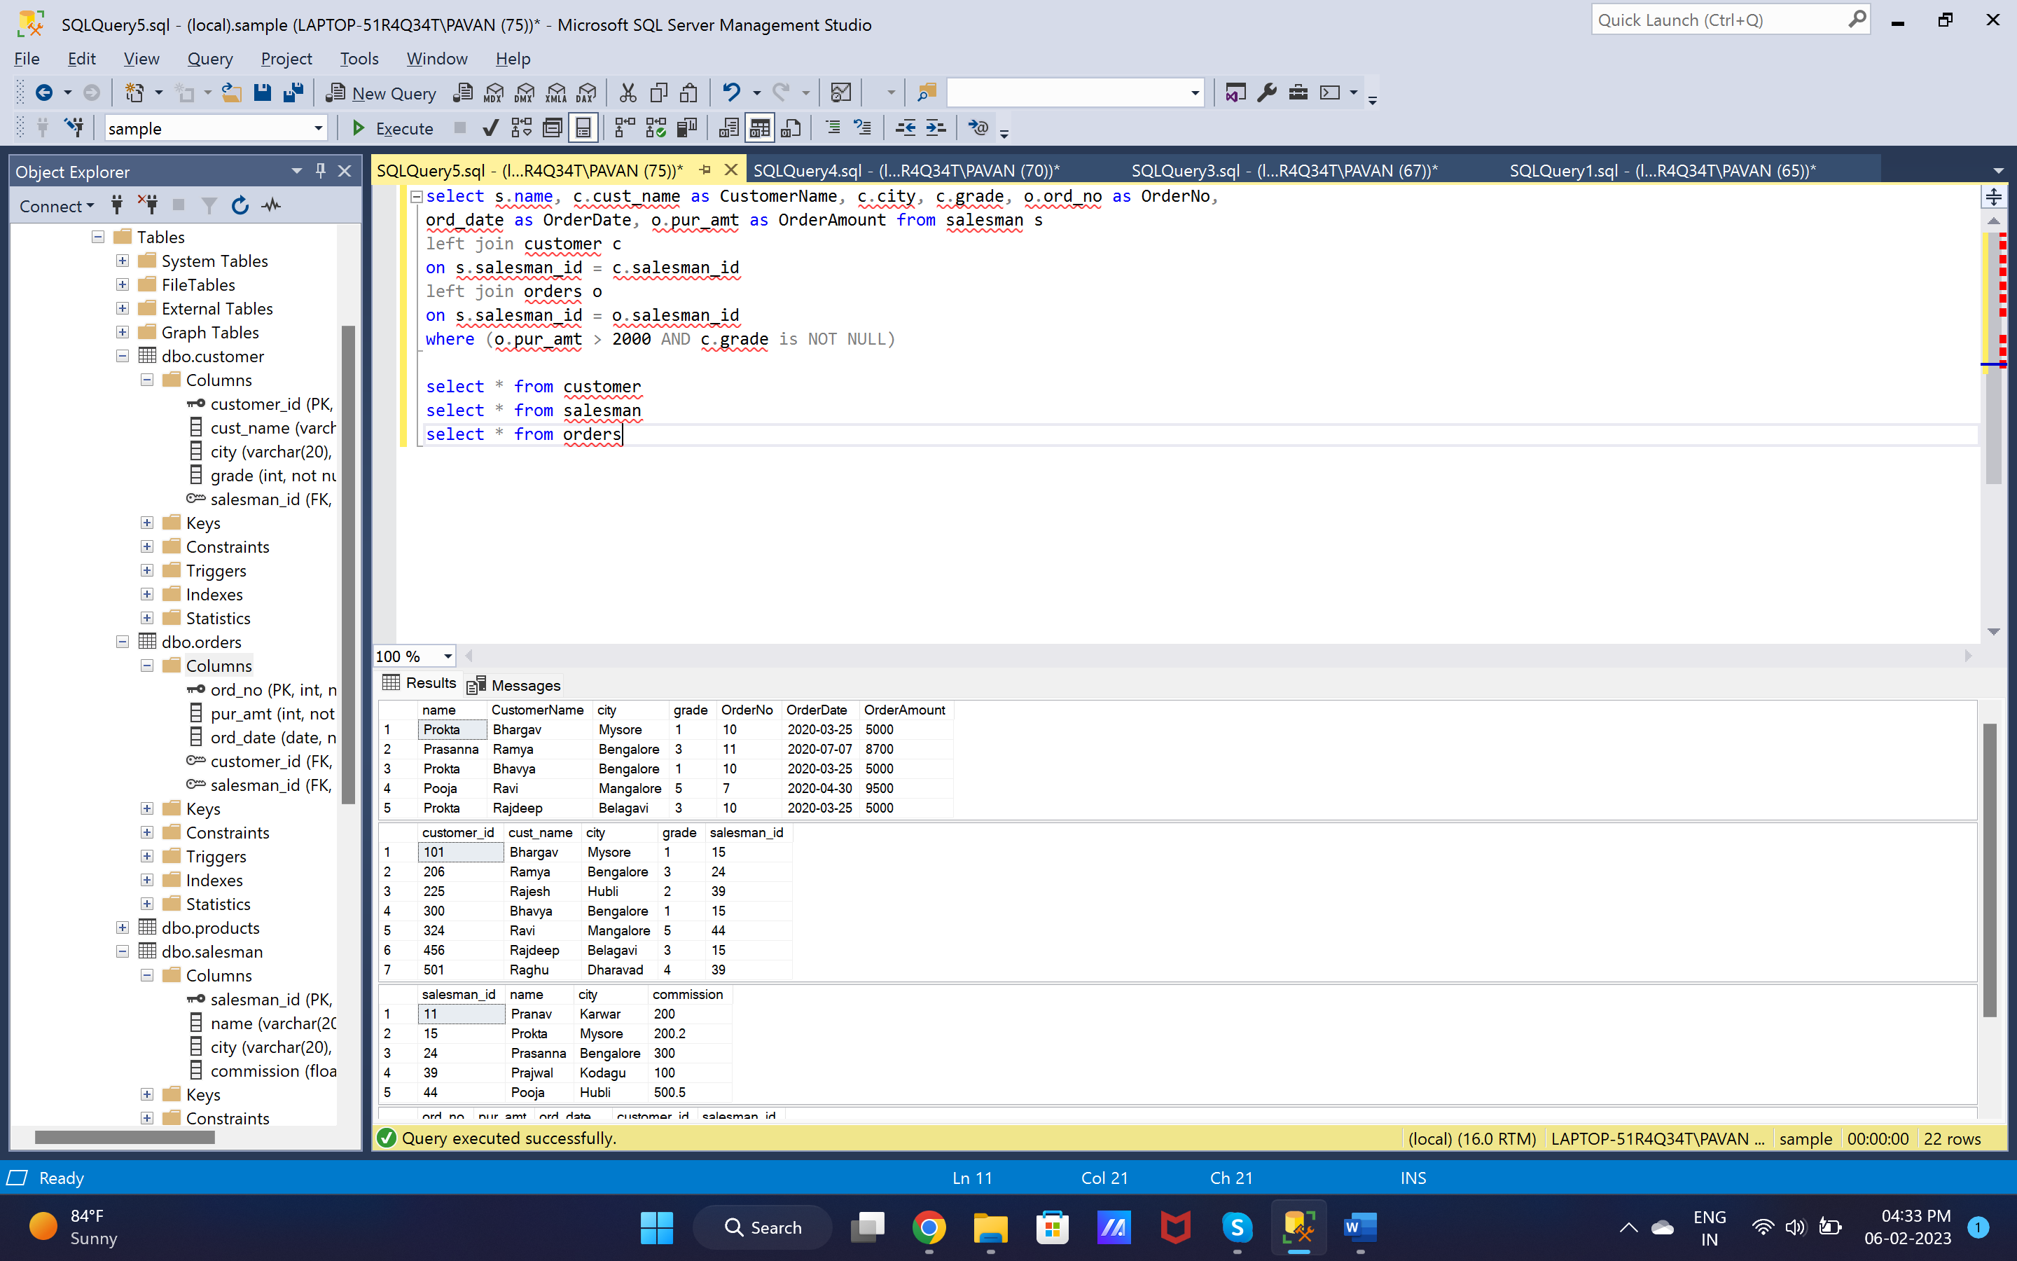

15. select s.name, c.cust_name as CustomerName, c.city, c.grade, o.ord_no as OrderNo,

ord_date as OrderDate, o.pur_amt as OrderAmount from salesman s

left join customer c

on s.salesman_id = c.salesman_id

left join orders o

on s.salesman_id = o.salesman_id

where (o.pur_amt > 2000 AND c.grade is NOT NULL)



16. select c.cust_name as CustomerName, c.city, o.ord_no as OrderNo,

ord_date as OrderDate, o.pur_amt as OrderAmount from salesman s

left join customer c

on s.salesman_id = c.salesman_id

full join orders o

on s.salesman_id = o.salesman_id

where c.grade is NOT NULL

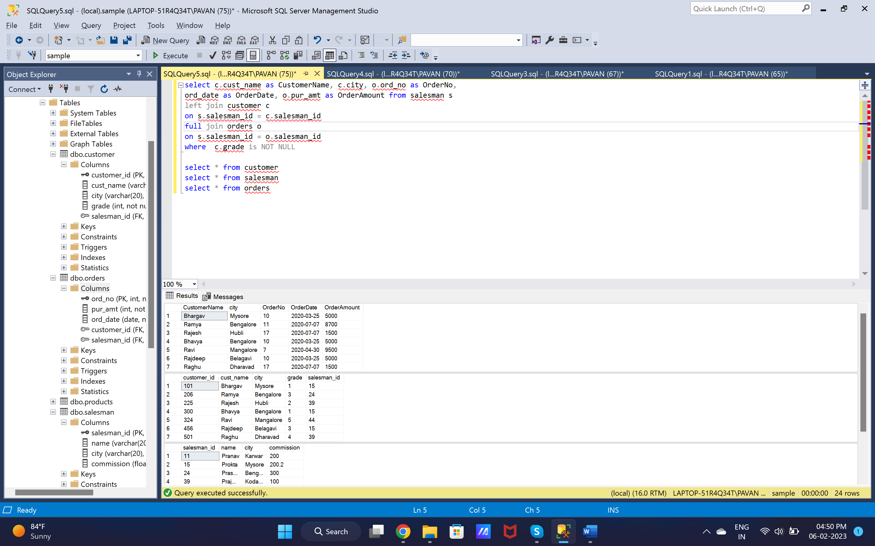

17. select * from customer

cross join salesman

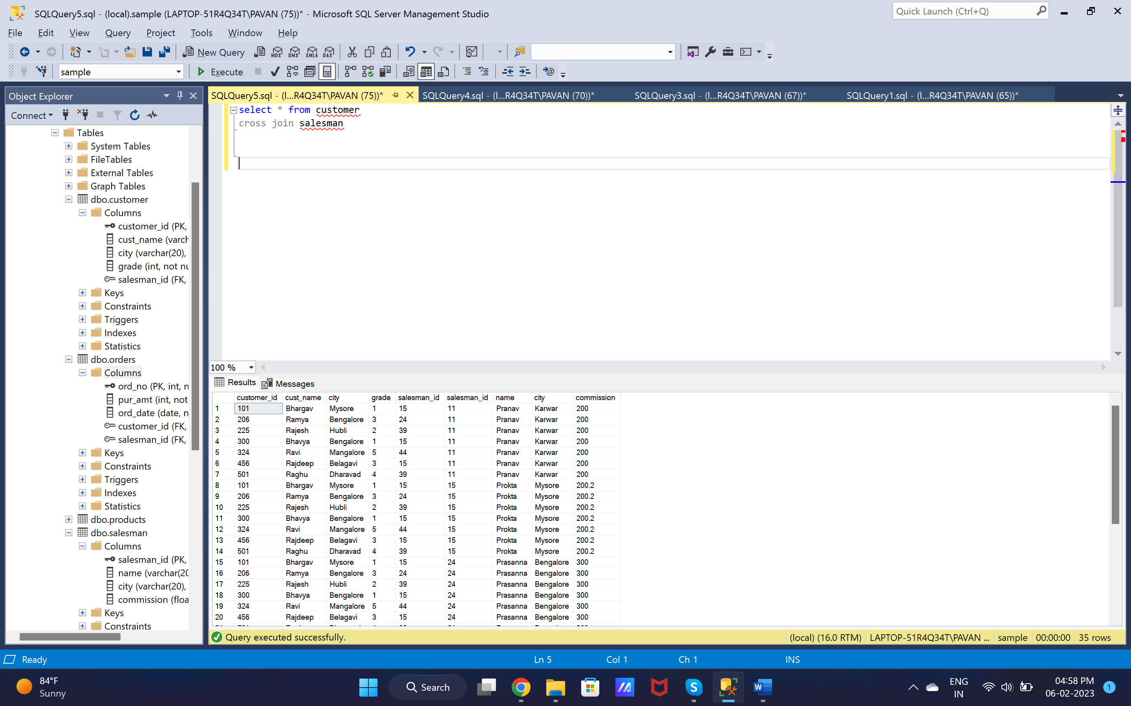

18. select * from customer c

cross join salesman s

where s.city – c.city

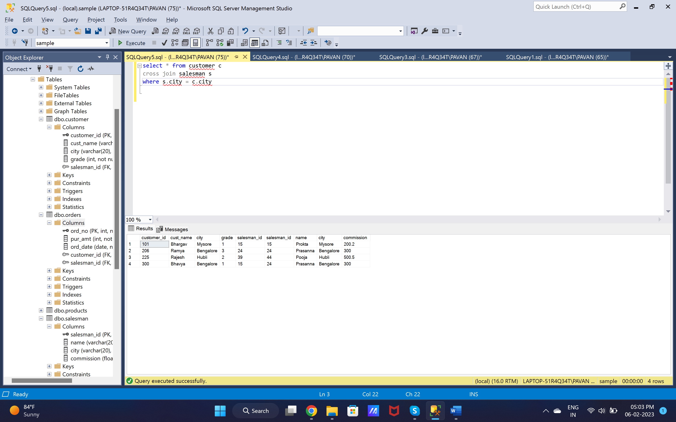

19. select * from customer c

cross join salesman s

where (s.city is not null AND c.city is not null) AND c.grade is not null

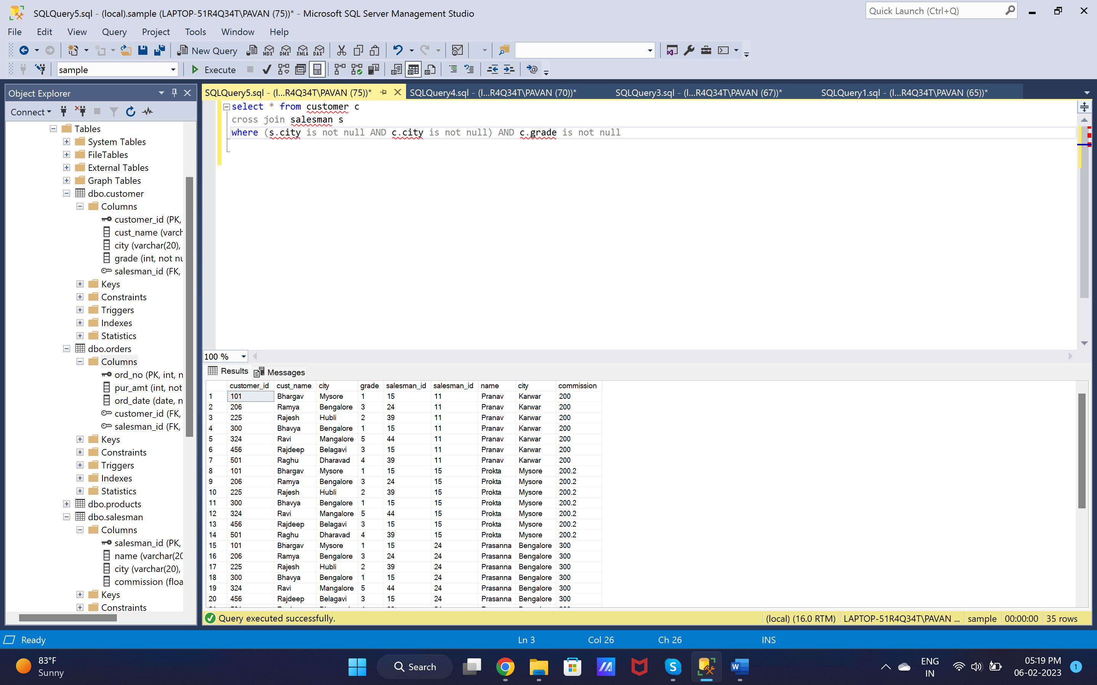

20. select * from customer c

cross join salesman s

where s.city != c.city AND c.grade is not null

